

Project Initialization and Planning Phase

Date | 30 June 2026
Team ID | xxxxxx
Project Name | Rising Waters
Maximum Marks | 3 Marks

Define Problem Statements (Customer Problem Statement Template):
Create a problem statement to understand your customer's point of view. The Customer Problem Statement template helps you focus on what matters to create experiences people will love. A well-articulated customer problem statement allows you and your team to find the ideal solution for your customers' challenges. Throughout the process, you’ll also be able to empathize with your customers, which helps you better understand how they perceive your product or service.

Example:
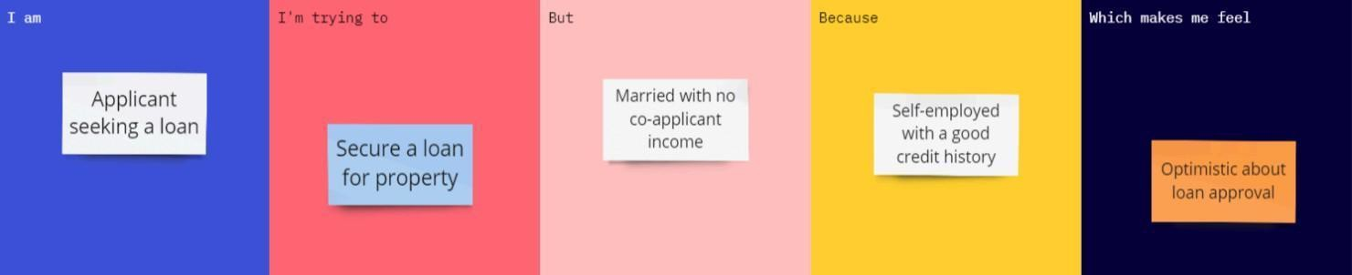

Problem Statemen t (PS) | I am (Customer) | I’m trying to | But | Because | Which makes me feel
PS-1 | A regional disaster management officer or local emergency response lead. | Quickly evaluate localized environmental changes to predict severe flash flood probabilities before the water actually enters residential zones. | Existing systems rely on manual monitoring or delayed weather reports, making it nearly impossible to analyze complex  multi-parameter climate variables  simultaneously. | Traditional methods lack real-time predictive analytics tools, which heavily delays early emergency alerts and evacuation planning. | Anxious about public safety, highly responsible for avoidable structural damage, and frustrated by the lack of reliable data-driven insights.

